**Cairo University**

**Faculty of Engineering**

**Systems & Biomedical Engineering**

**Health Information Systems:**

**“Cardiomatic Clinic”**

**Phase II**

**Front End &Database**

**Under Supervision:**

Professor, Eman Ayman

Eng. Yara Wael

**Team Members:**

1. Fady Mohsen Magdy
2. Rana Ibrahim Nagy
3. Sondos Mahmoud
4. Mohamed Moselhi
5. Mohamed Sayed Diab
6. Reem Adel

**Abstract:**

This report documents the progress made in the development of health information systems for the Cardiomatic Clinic, focusing on the completion of 50% of the project milestone, specifically the front end and database implementation. It highlights the methodologies, technologies, and outcomes of the front end and database development phases, and the integration of APIs.

**Introduction:**

The Cardiomatic Clinic's health information systems project aims to streamline clinical workflows, improve patient care, and enhance operational efficiency through the implementation of a comprehensive information management system. This report provides an overview of the project progress, focusing on the completion of 50% of the project milestone, covering front end and database implementation, and the integration of APIs.

**Project Overview:**

The project involves the development of health information systems tailored to the specific needs of the Cardiomatic Clinic. It encompasses various modules, including patient portal, appointment management, billing, and reporting. The completion of 50% of the project milestone signifies significant progress towards achieving the project goals.

**Front End Development:**

Front end development tasks were divided among team members to ensure efficient implementation of user interface components. Technologies such as React.js were utilized to build dynamic and responsive front end interfaces. The developed front end interface includes features such as patient registration, appointment scheduling, and medical record access.

**Database Implementation:**

Database design focused on ensuring efficient storage and retrieval of clinical data while maintaining security and scalability. SQL databases, such as PostgreSQL and Prisma , were used for transactional data storage. The database schema was designed to accommodate various data entities, including patient profiles, appointments, medical records, and billing information.

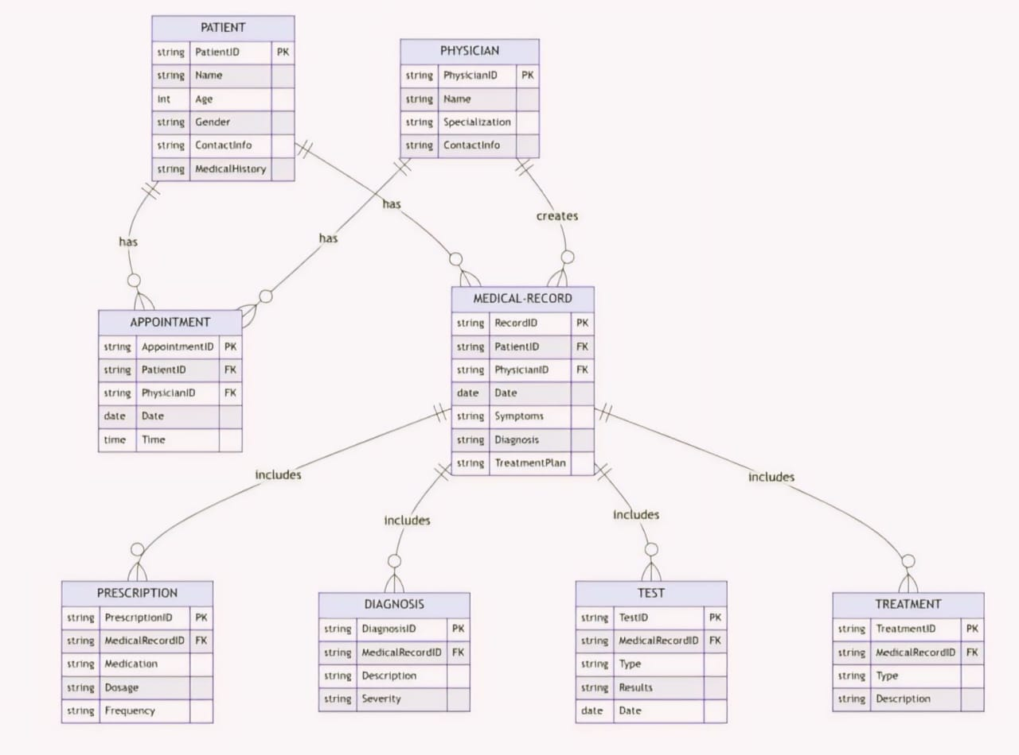

**Integration of APIS:**

**Methodology:**

Agile methodologies were adopted for front end and database development, allowing for iterative and incremental progress. Continuous integration and deployment (CI/CD) pipelines were utilized to streamline the development process and ensure code quality. Regular sprint reviews and retrospectives facilitated collaboration and feedback among team members.

**Results:**

The front end development phase resulted in the successful implementation of a user-friendly interface with intuitive navigation and seamless integration with backend services. The database implementation phase led to the creation of a robust and scalable data storage solution, capable of handling the clinic's information management needs.

**Login:**

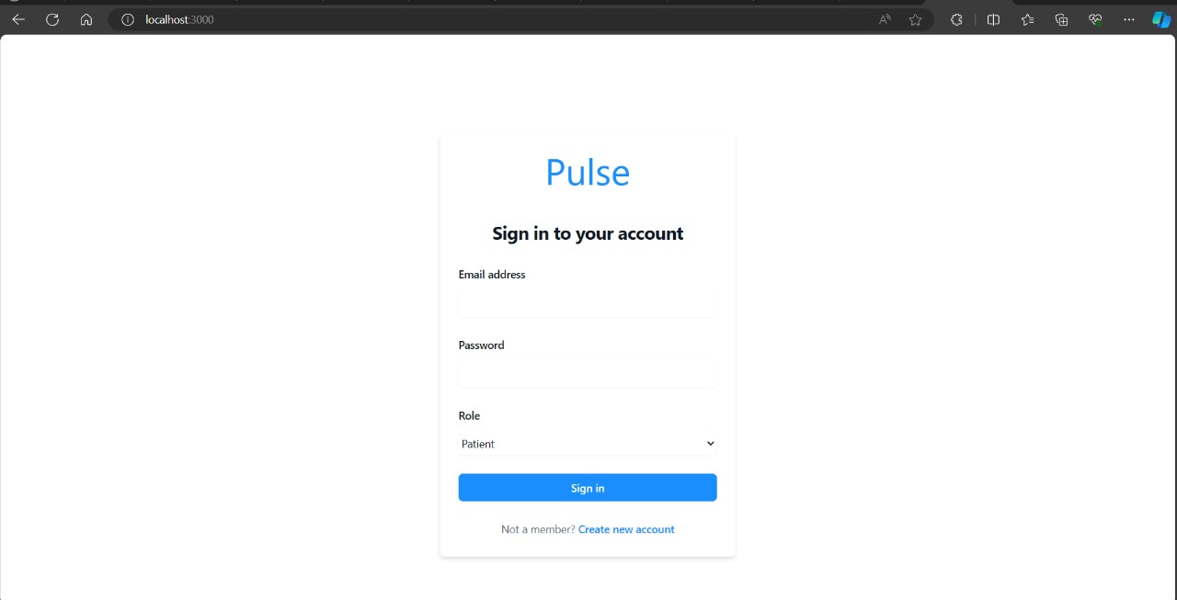

**Sign-up:**

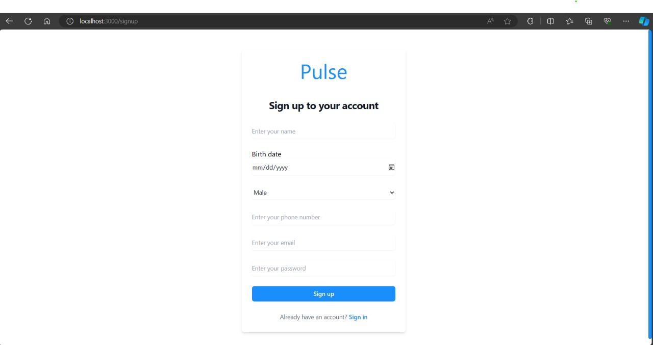

**Homepage:**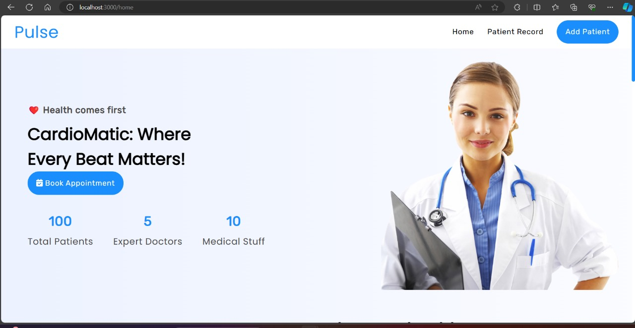

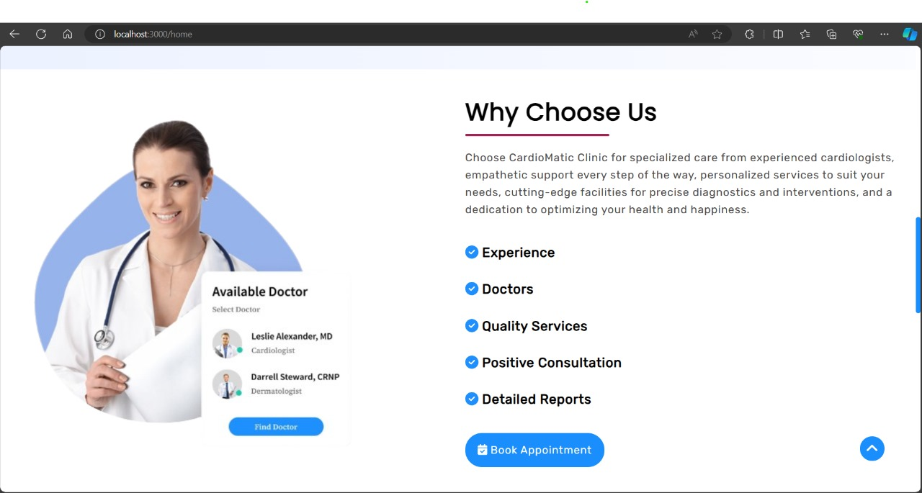

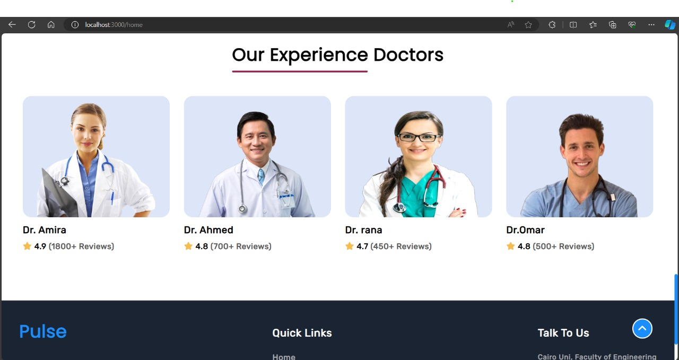

**Patient record:**

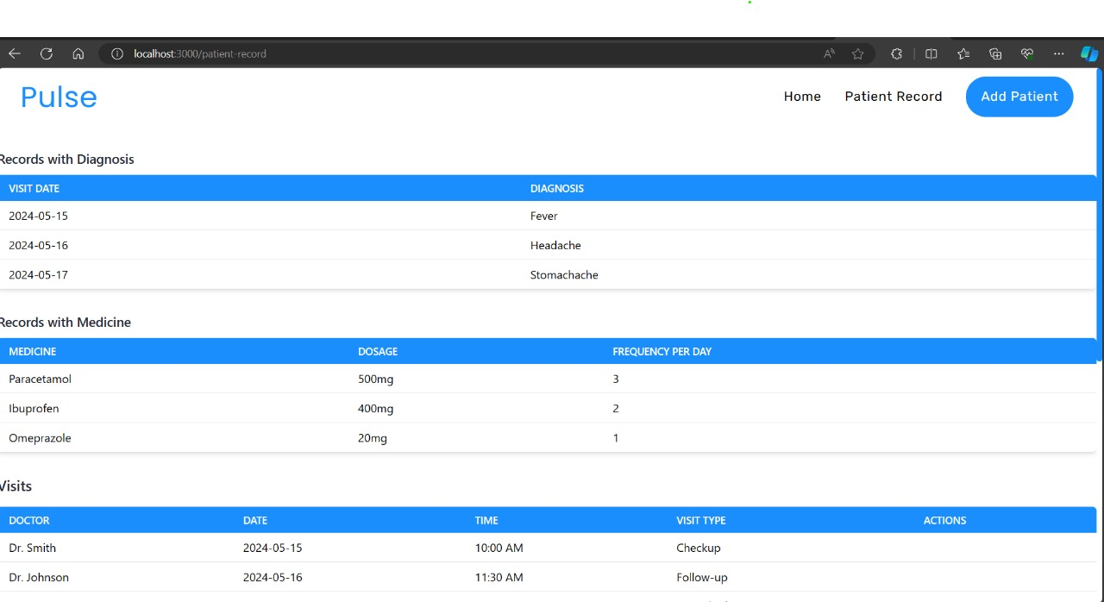

**Book Appoitment:**

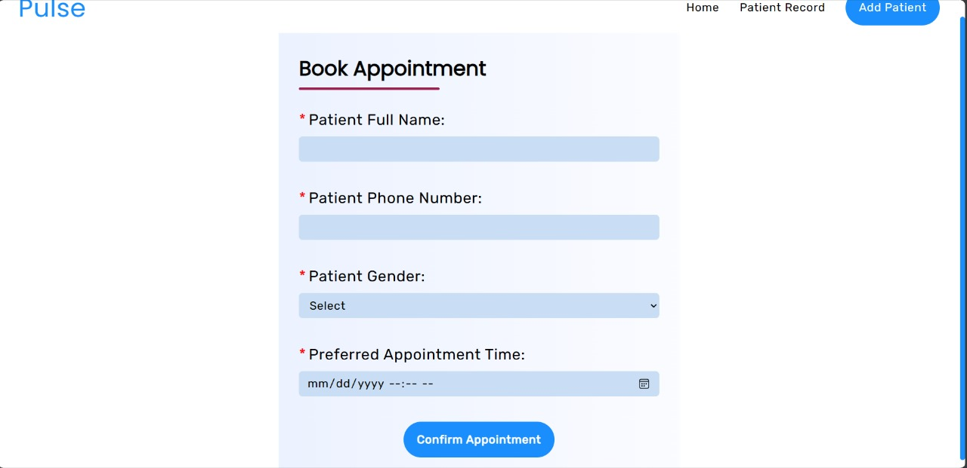

**Add patient:**

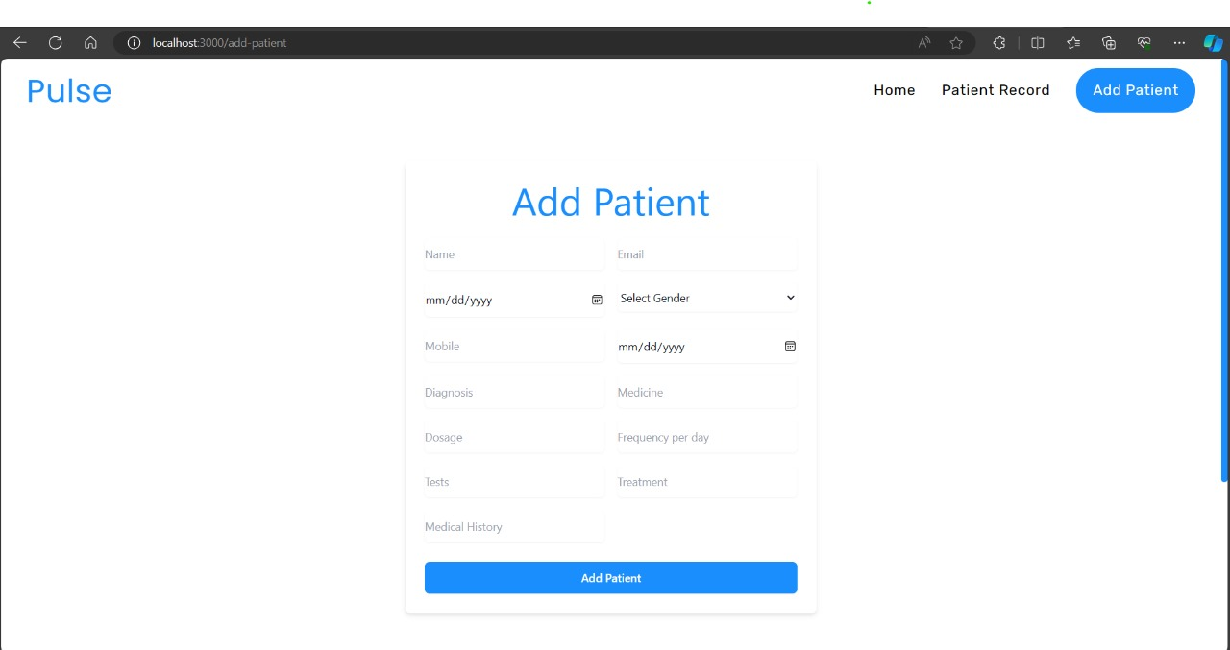

**Remaining phases:**

While significant progress has been made in completing the front end and database implementation, , and the integration of APIs. It's essential to acknowledge the remaining phases of the project. These include backend implementation, as well as additional frontend functionalities such as viewing records for patients.

**Conclusions:**

**Future Directions:** Looking ahead, the completion of the front end and database implementation lays a solid foundation for the remaining phases of the project. The successful execution of these phases will enable the Cardiomatic Clinic to realize its vision of implementing comprehensive health information systems that streamline clinical workflows and enhance patient care.

**Next Steps:** In the next phase of the project, the focus will shift towards completing the remaining modules, including user authentication and authorization, patient portal development, appointment management system enhancement, billing and invoicing automation, reporting and analytics, quality assurance, deployment, documentation, and training. Each of these phases will be executed with careful attention to detail and adherence to project requirements and standards.